WEEK 2 BASIC VULNERABILITY SCANNING AND PENETRATION TESTING

Fig 1.NMAP – PORT SCANNING
Command to run:nmap -sS -A 192.168.1.1
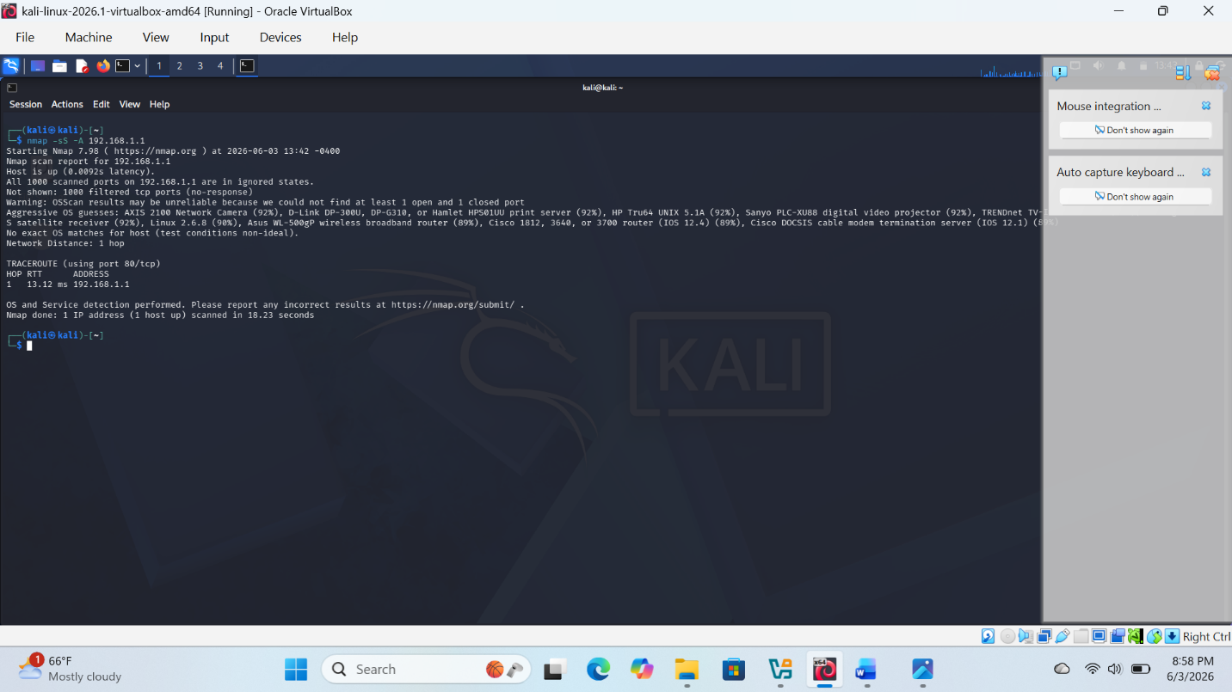

Fig 2.Network scan
Command:nmap 192.168.1.0/24
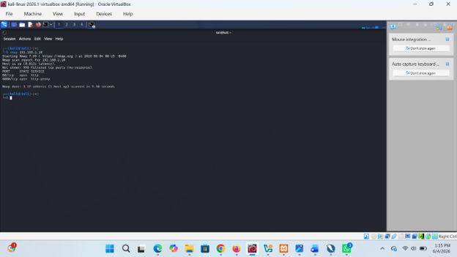

Fig 3. Vulnerability scanning
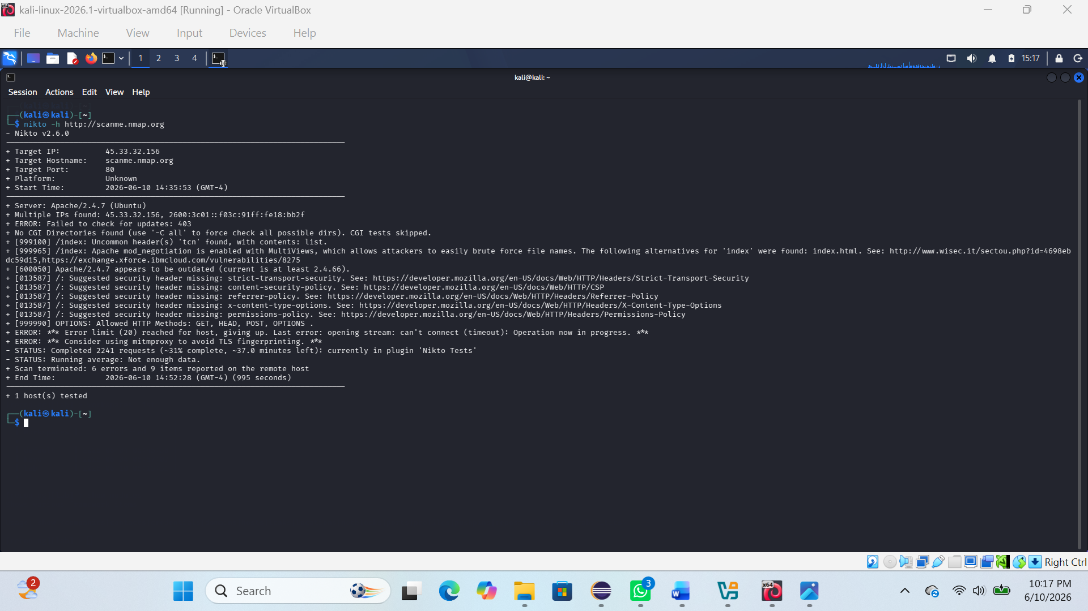

WEEK 2 REFLECTION
Penetration testing basics were explored through practical use of Nmap for scanning systems and identifying open ports and services. This helped build understanding of how attackers map system exposure and how security professionals assess vulnerabilities in networks.

